Containers for Winter Seed Sowing

- You can use any container that holds at least 3-4" of potting soil/mix, and has headroom for the seedlings to grow (2"+ is good)
- and is translucent enough to let light through. Milk jugs are not required,

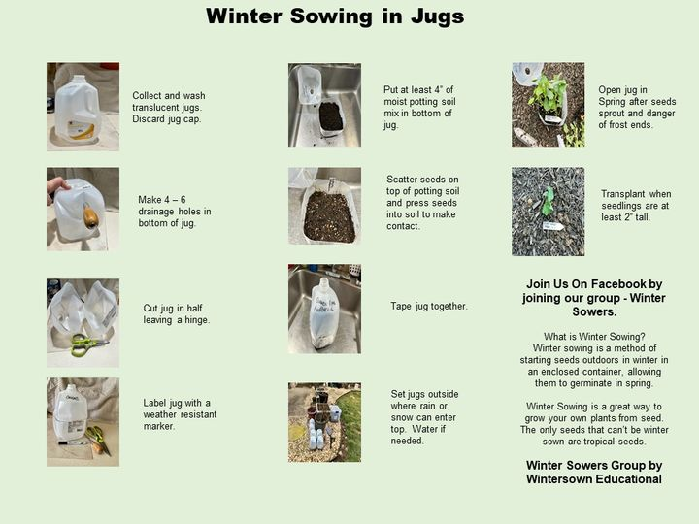

- make drainage holes in the bottom

- fill container with potting soil/mix and moisten well. Water well and let drain. If your container is "too wet" after watering, you don't have enough drainage holes. Remember, these are going to be outside getting rained and snowed on and melting will occur

- Sow your seeds, press small seeds into the top of the soil to make contact, and large seeds you can cover lightly. Start with perennials that need cold stratification and move onto hardy annuals, then tender annuals later

- mark your containers with what you've planted. Fading can occur so mark where/how the sun won’t fade and put a plant marker inside as backup!

- close/cover container securely (tape or otherwise) and make ventilation holes on top that will also allow rain/snow to get in. If using jugs or bottles, no additional holes necessary, caps stay off bottles!

- put outside right away (anywhere they will get light) and precipitation

- It doesn't matter where you place your containers as long as they are safe and get light, rain and snowed on (snow not required for winter sowing)

WINTER SOWING
Copied from
Facebook page of Turdi Davidoff

